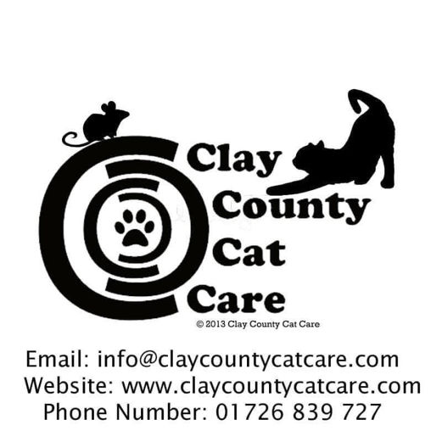

Donate to Clay County Cat Care

Direct Debit

Sort Code; 54-41-12
Account Number; 46240667

